GICHITWAA-GIIZHIGAD-OON SAUGEEN STONE FESTIVAL
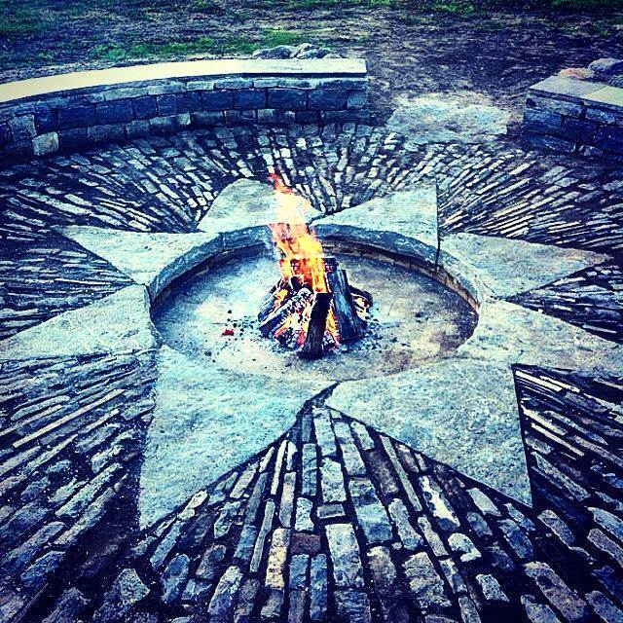
August 15, 16 and 17th 2015
911# 6418 Kings Highway #21, Chippawa Hill Saugeen First Nation N0H 2L0

Three days of First Nation Crafts and Dry Stone Walling
View the largest dry stone walling project in North America being constructed by Saugeen First Nation
Witness the creation of an Iron Age Dry Stone Roundhouse built by the wallers of Saugeen and their International Walling guests
Saugeen First Nation vendors will be on hand to display their skills and sell their crafts.
It will be a celebration of stone, arts and crafts, the environment and community
This three day event includes talks, tours, workshops, live music and children’s activities.
The Festival will bring together carvers, masons and artists from Saugeen.
2nd International Canadian Dry Stone Walling Competition
Interested vendors please contact Jennifer Kewageshig Manager/Employment and Training
519-797-1224 or employment@saugeenfirstnation.ca
2 Day Dry Stone Walling Course, August 16,17, taught by certified DSWA UK Instructors. Learn the basics of dry stone walling! $300 for the course and it includes lunch and shirt! ($250 for LO and First nation Members)
Contact Dean McLellan for details, hlmasonry@ehtel.ca.

